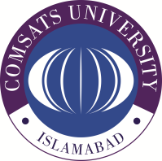**COMSATS University Islamabad, Wah Campus**

**Assignment # 01**

Department of Computer Science

|  |  |  |  |  |  |  |  |  |
| --- | --- | --- | --- | --- | --- | --- | --- | --- |
| Class/Program: | | **BS(SE)-5A, BS(CS) –5A,C,D** | | Date: | **Feb 26, 2024** | | | |
| Subject: | **Database System** | | | Instructor: | | **AYESHA NAEEM** | | |
| Total Time Allowed: | | |  | Maximum Marks: | | | | **10** |
| Student Name: | |  | | Registration #: | | |  | |

**Q 01: [C1, CLO-1]**

**Question # 01: (10)**

What are the current database challenges?